horizontal line

**Takouba Security**

Veterans Affairs

Participatory System Dynamics Platform   
(to Increase Timely Access to VHA Evidence-based Outpatient Mental Health Care)

**Design Document -- Iteration A**

Mon 09-Oct 2017  
Version 6

horizontal line

# Document History & Status

|  |  |  |
| --- | --- | --- |
| Version | Date | Description/ Status |
| v 1 | 14-Aug 2017 | Development |
| v 2 | 29-Aug | Development / after Session 1 (21-25 Aug) with client. Added info on [Graphic Standards](#_9t9hm0tvvbos). |
| v 3 | 18-Sep | Edits based on revised schedule (and features clarifications/edits across Iterations), use of XLS instead of CSV. Page Groups and Flows. |
| v 4 | 02-Oct | Version to send to LZ. Added latest UI screens, screen flow, descriptions of functionality across “SOW Requirements”. |
| v 5 | 07-Oct | Updated screens. |
| v 6 | 09-Oct | Release version for development. |

**Table of Contents (Quick Links)**

[Document History & Status](#_oymnw3nlvwib)

[Objective of This Document](#_14mpx6a8znb7)

[Basics](#_i8pbfw3z53o2)

[Iteration Objectives](#_sni7x0g8kgeh)

[Key Dates](#_bxjlqlo0jwfy)

[Graphic Standards and 508 Accessibility Standards](#_9t9hm0tvvbos)

[Forio Notes and Terminologies](#_an63jzdmeaaw)

[Vensim Model(s)](#_einp74qozghl)

[Page Flows and Wireframes](#_o1ha0ebcyf97)

[Page Groups & Flows](#_fex258bnlmwe)

[Wireframes](#_3jxylyy5msj7)

[Phone and Computer/Tablet Design Concepts](#_p7kl937rqu95)

[SOW Requirements](#_8i34yjdfg0da)

[2.01 General Functionality / 5.1.1. General Login Page](#_sqtvoq95gp4)

[2.03 Player’s Dashboard / 5.9.1 General Player Functionality](#_m9qc9yb6976j)

[2.03 Player’s Dashboard / 5.9.2 Introductory Screen with Role-information and Background](#_4cl3fk6lbqvy)

[2.03 Player’s Dashboard / 5.9.3 Ability to upload team-member pictures](#_1jg0scn7blu)

[2.03 Player’s Dashboard / 5.9.5 Timeline information, tracking progress against schedule](#_7w5ll2vo71sr)

[2.03 Player’s Dashboard / 5.9.6 Dashboard with access to key metrics](#_uwhmw4nfeoyt)

[2.03 Player’s Dashboard / 5.9.10 Decisions Page](#_nyt4n4am3mch)

[2.03 Player’s Dashboard / 5.10.1 Introduction & Help: Text-based 'prepare' section](#_u9nb13913xic)

[2.03 Player’s Dashboard / 5.10.2 Introduction & Help: Text-based 'help' section](#_vlo71xzglvyx)

[2.03 Player’s Dashboard / 5.10.3 Integrate tutorial videos](#_9egfdrbbt149)

[2.08 Managing/Facilitating Simulations / 5.6.1 Open/Close Access to Simulation](#_nkjgzks0rt49)

[General Requirements](#_c3hrapiy8c2p)

[Managing Multiple Vensim Models](#_xr1mf981mld8)

[Managing XL files](#_ty80q6xfqbg1)

[Iteration A Design-Related Questions](#_vmohjbf4vzow)

[Recordings of Calls](#_tgf0cxp1ylib)

[Glossary](#_6x8rkjwa8fzc)

[Appendix](#_h9hh913o27nk)

Notes on Colors:

1. Most text is in black
2. We can use text color for different indications. For example, Purple is used as notes from Takouba about questions or items yet to be resolved.
3. Orange is to indicate a recent questions from WaferWire.
4. When questions are acknowledged/resolved we can turn it Dark Green 1, then eventually, back to black.

# Objective of This Document

1. This document describes the design for “Iteration A” for the Participatory System Dynamics Platform.
2. The document is also used to track questions and clarifications during the development and potentially the testing phases of the project.
3. This document does NOT describe all the work to be performed during the Iteration A development period. For example, we will want to work on understanding Forio features for subsequent Iterations. We will also want to investigate SSO options, even though SSO is part of Iteration C.

# Basics

## Iteration Objectives

Original

1. ~~Iteration A: Logon, basic UI, screen flows, initial input/output.~~
2. ~~Iteration B: Reports and output, user input, gameplay, monitor decisions, chat.~~
3. ~~Iteration C: Integration, SSO, data connections, user/access management, videos.~~
4. ~~Iteration D: Full feature v1.0.~~

Revised (29-August) XXX

1. Iteration A: Logon, basic UI, screen flows, initial input/output (few example elements).
2. Iteration B: Select model/data, initial reports and output, initial user input, gameplay and session.
3. Iteration C: Chat, monitor decisions, compare games, user/access management, videos and training-related, additional inputs and outputs.
4. Iteration D: v1.0

## Key Dates

Dates have been revised and confirmed on Fri, 01-Sep. These dates match the dates on page 5 of “PSD\_TAK\_Revised\_Workplan\_HCP2.pptx”.

1. Design Finalized Date: Mon 09-Oct
2. WW Development Due Date: Mon 30-Oct
3. Submit to Client Date: Mon 06-Nov

## Graphic Standards and 508 Accessibility Standards

1. **General Design Considerations:**
   1. The Designs shall conform to the Veterans Affairs color schemes (CMYK):
      1. Navy Blue: 100, 58, 9, 42
      2. Lt Blue: 98, 24, 1, 3
      3. Red: 10, 100, 100, 10
      4. Green: 57, 11, 85, 45
      5. Gray: 33, 14, 11, 31
   2. The Designs shall use the Team PSD Logo as illustrated in the artist’s concepts below and available through the links in [Appendix](#_h9hh913o27nk) below.
2. We need to make the UI “Section 508 Accessibility Standard” compliant
   1. Purpose: “address access for people with physical, sensory, or cognitive disabilities. They contain technical criteria specific to various types of technologies and performance-based requirements which focus on functional capabilities of covered products“
   2. We plan to use the Iterations to test various aspects of compliance
   3. There is a group within the VA who will test for compliance
   4. References
      1. <https://www.access-board.gov/guidelines-and-standards/communications-and-it/about-the-ict-refresh>
      2. http://webaim.org/standards/508/checklist
      3. https://sunlightfoundation.com/2009/01/27/section-508-compliance-easier-you-think/
      4. http://www.msktc.org/lib/docs/KT\_Toolkit/Charts\_and\_Graphs/Charts\_and\_Graphics\_508c.pdf
3. Look and feel should support the materials being developed for the Workshops.
   1. Example graphics

**Figure 1**

|  |  |  |  |
| --- | --- | --- | --- |
| complexity.png | circles.png | dialog_in_modeling_process.png | make_dynamics_explicit.png |
| mental_model.png | interconnectedness.png | reinforcing_loop.png | balacing_loop.png |

* 1. Note the color and use of curves/lines.
  2. The graphics above are for use in the Workshop materials. We want our UI to support and have a similar look and feel.

1. Official standards
   1. The links below also have information about fonts, use of logos, and 508 compliance. If there are questions or issues with the standards or compliance, let’s discuss and see if we can use the Iterations to test.
   2. Links
      1. [Tier 1 Graphic Standards](https://www.va.gov/opa/publications/graphicstandards/va_graphicstandardsguide_508_0113.pdf) (Aug 2012)
      2. [Graphic Style Guide](https://www.vets.gov/playbook/downloads/VHA_Style_Guide_508.pdf) (508 compliant, Feb 2012)
      3. [VA Mobile Style Guid](https://mobile.va.gov/sites/default/files/files/VAMobileStyleGuide508compliant.pdf)e (508 compliant, Jul 2014)

## Forio Notes and Terminologies

1. Notes and Terminology:
   1. Project
      1. Collection of "Groups"
   2. Groups
      1. Analogous to a "Class"
      2. Collection of "Worlds"
      3. Has 1 "superuser"
      4. “Group ID”s must be unique, so we will use “Group ID” in the following format to indicate team: “Team ” + team + “ , ” + Location”. Examples:
         1. “Team Telehealth, Menlo Park”
         2. “Team ATS, Stockton”
   3. World
      1. Collection of "Users"
      2. Can have multiple runs
      3. Can only have 1 "Active" run
   4. Run
      1. An "instance" of a model with input and output variables
   5. In this case 1 Run = 1 Model File + 1 XL file combination
2. How to get the "Right" run:
   1. Users choose model file
   2. Get CSV files from the World Name / admin set it up
   3. Use this information to create a run -> This is stored in a cookie by EpicenterJS

## Vensim Model(s)

1. For all Iterations, the name of the Vensim file(s) will be:
   1. CC\_PROD.vmf
   2. MM\_PROD.vmf
   3. Psy\_PROD.vmf
   4. Agg\_PROD.vmf
2. For Iteration A, the CC\_PROD is based on “CC\_Dynamic v6 labeled.mdl”, pulled from GitHub on Sun 08-Oct 2017.
3. For Iteration A, we are also using “Work\_Modified.vmf” to illustrate ability to select between different Vensim models in the simulation.
4. The descriptions that are contained in this document will apply to when the team member has selected “Care Coordination”.
5. If the team member has selected “Medical Management”:
   1. The simulation will load Work\_Modified.vmf.
   2. The overall pages, page flow, sections, tiles, navigation, etc. will still be in place as described in this Iteration A Design document, but the Play Mode - Decisions tile and Play Mode - Outputs will reflect the variables from Work\_Modified.vmf.
   3. Using Work\_Modofied.vmf is only for demonstrating the ability to select between multiple Vensim files, so there is no need to provide Play Mode Model diagram.
   4. However, the features described for the other pages such as Train, Chat, and Administer should still be active.
6. For more information, please see section 2.d under [Phone and Computer/Tablet Design Concepts.](#_p7kl937rqu95)
7. The XL spreadsheet with data for testing is provided in “ModelParameters.xlsx” under sheet: “CCParams”.

# Page Flows and Wireframes

## Page Groups & Flows

We expect to have the following “Page Groups”, where each box is a Page Group. A Page Group may be one or more pages.

**Figure 2**

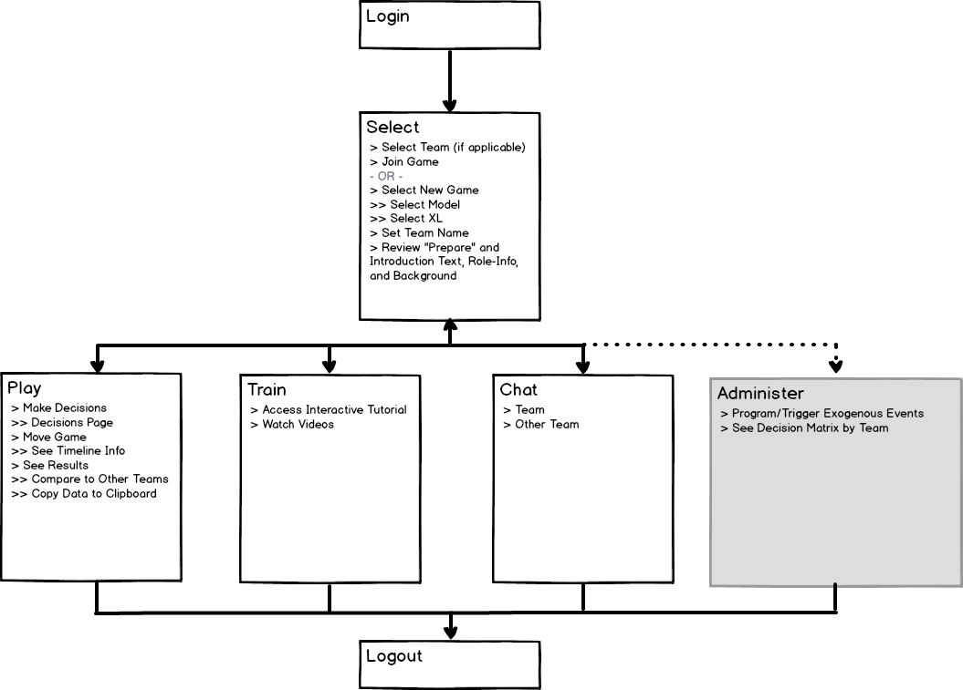

1. Login
2. Select
3. Play
4. Train
5. Chat
6. Administer (only for Administrator)

The following Table describes the Pages (or Sections or Tiles) in each Page Group.

|  |  |  |
| --- | --- | --- |
| Page Group | Page / Section / Tile | Description / Requirements |
| Select | 1. Main | 1. User can join an existing game or start a new game. 2. Existing game → page shows model selected and calendar status (and XL file selected?) 3. New game → select model and XL file 4. Note: we still have to investigate how Forio handles game status, teams, groups, etc. |
| Select | 2. Welcome | 1. Introductory text 2. Basic info, including navigation info (click “Play” to …) 3. “Prepare” info |
|  |  |  |
| Play | 3. Model |  |
| Play | 4. Gameplay | This is embedded into the “Model” tile. |
| Play | 5. Decisions |  |
| Play | 6. Outputs | 1. Graphs 2. Export (csv) 3. Compare Scenarios (and we need to determine what ARE scenarios) 4. Copy data to clipboard |
|  |  |  |
| Train | 7. Main | 1. Basic info and intro |
| Train | 8. Text-based help | 1. with expandable topics? |
| Train | 9. Video-based help | 1. Video-based help (phone: landscape) |
|  |  |  |
| Chat | 10. Group/Team |  |
| Chat | 11. Facilitator to Team |  |
| Chat | 12. Facilitator to Team Member |  |
|  |  |  |
| Admin | 13. Team Decisions | 1. Decision matrix by team |
|  | 14. Exogenous Events |  |

## Wireframes

We describe the general browser-viewed wireframes (including navigation and page layout) for the Phone Concept and Computer/Tablet Concept below.

1. Phone  
   In general, the phone layout will have the following elements, user interactions, and screen behaviors.

**Figure 3**  
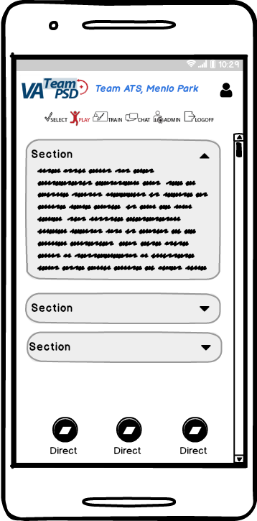

* 1. Top Section
     1. The Top section will contain
        1. Team PSD Logo
        2. Team name (example “Team ATS, Menlo Park”) = Forio.”Group ID”.
        3. User picture and name
        4. Top Navigation
     2. The **Top Navigation** contains “Select”, “Play”, “Train”, “Chat”, and “Logout” links (see below). For administrators, there is also a “Admin” link. The Top Navigation also contains the name of the user’s team on the left, and on the right, a picture of the user, and the user’s name. The user navigates to the main page of the Page Group by touch or click, which turns the icon red to indicate the mode. Below is a brief description of each mode:

Figure 4



* + - 1. **Select** Mode is the main menu that enables the user to select the model to simulate, the source data file and the option to join an existing simulation, or start a new one.
      2. After the user selects the model and data, the user will be guided to enter into **Play** mode. Play mode enables the user to input decisions and analyze outputs.
      3. **Train** mode provides the user with text and screencast about how the simulation is operated by the user. It will organize topics logically for easy reference.
      4. **Chat** Mode provides the user with an interface to exchange text information with other members of the team. In addition to the icon link, the graphic will indicate when a new chat or message is available (for example, an exclamation point overlay in the corner of the icon)
      5. **Admin Mode** provides the user with an interface to view decision matrices and enter exogenous information to the model.
      6. **Logoff** enables the user to safely close the session.
    1. The top section will persist in all pages (except for Login and Successful Logout acknowledgement page).
  1. Middle/Content
     1. Depending on the specific page, there will be one or more sections for the content. In general
        1. The content sections will all be collapsable/expandable using the triangle on the URH corner of the section.
        2. Upon loading the page, the first section will render expanded as a default, with the subsequent sections collapsed as a default.
     2. The Middle/Content area is scrollable.
  2. Bottom Navigation
     1. Depending on the page, there will be icon-based navigation buttons that persist at the bottom of the browser.
     2. Clicking on the icon will take you to the section (i.e., scroll down/up to the page anchor that corresponds to the section) and expand the section that is selected.
     3. The Bottom Navigation the bottom of the screen enables the user to click on an icon to quickly scroll down/up to the page anchor of the corresponding section, which is arrayed below the Model Tile. For examples of such persistent bottom navigation, please see:
        1. <http://www.resoluut.com/showcases/red-dot-awards-2017/>
        2. <http://miyamotointernational.com/> (notice “Carat” at LRH corner to navigate back home)

1. Computer/Tablet  
   In general, the Computer/Tablet layout will have the following elements, user interactions, and screen behaviors.

Figure 5  
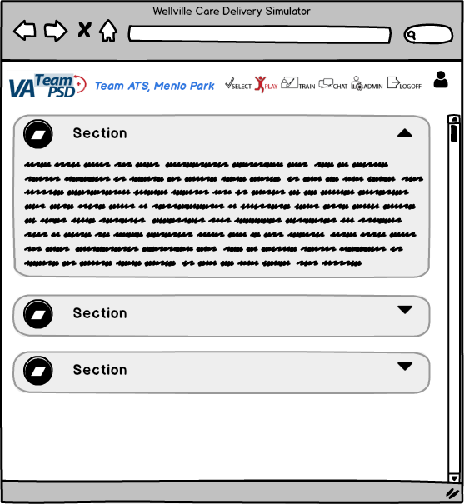

* 1. Top Section
     1. The Top section will contain
        1. Team PSD Logo
        2. Team name (example “Team ATS, Menlo Park”) = Forio.”Group ID”.
        3. User picture and name
        4. Top Navigation
     2. The **Top Navigation** contains “Select”, “Play”, “Train”, “Chat”, and “Logout” links (see below). For administrators, there is also a “Admin” link. The Top Navigation also contains the name of the user’s team on the left, and on the right, a picture of the user, and the user’s name. The user navigates to the main page of the Page Group by touch or click, which turns the icon red to indicate the mode. Below is a brief description of each mode:

Figure 6



* + - 1. **Select** Mode is the main menu that enables the user to select the model to simulate, the source data file and the option to join an existing simulation, or start a new one.
      2. After the user selects the model and data, the user will be guided to enter into **Play** mode. Play mode enables the user to input decisions and analyze outputs.
      3. **Train** mode provides the user with text and screencast about how the simulation is operated by the user. It will organize topics logically for easy reference.
      4. **Chat** Mode provides the user with an interface to exchange text information with other members of the team. In addition to the icon link, the graphic will indicate when a new chat or message is available (for example, an exclamation point overlay in the corner of the icon)
      5. **Admin Mode** provides the user with an interface to view decision matrices and enter exogenous information to the model.
      6. **Logoff** enables the user to safely close the session.
    1. The top section will persist in all pages (except for Login and Successful Logout acknowledgement page) -- i.e., only the Middle/Content area will be scrollable
  1. Middle/Content
     1. For the layout for the Play pages, see the UI described in the Play Mode below (Figure 7). Instead of the Navigation Menu, users have access to the tiles on the right-hand side of the screen, with each tile allowing collapse/expand. Default is collapsed.
     2. Depending on the specific page, there will be one or more sections for the content. In general
        1. The content sections will all be collapsable/expandable using the triangle on the URH corner of the section.
        2. Upon loading the page, the first section will render expanded as a default, with the subsequent sections collapsed as a default.
     3. The Middle/Content area is scrollable.

## Phone and Computer/Tablet Design Concepts

1. **Login** is the home page referenced by the URL.
   1. The team member will log in with a password. If the team member is a member of more than one team, the user will have to select the team to play.
   2. After a successful login, the Select Mode and associated page.
   3. For more information, see [2.01 General Functionality / 5.1.1. General Login Page](#_sqtvoq95gp4)**.**
2. **Select Mode** is selected by the user by tapping the “select” icon on the top menu or after successfully logging into the simulation. The user will be presented with the Main Section expanded. The Main Section will give the user a choice to “Join Current Game” or to “Start New Game.”

Figure 7  
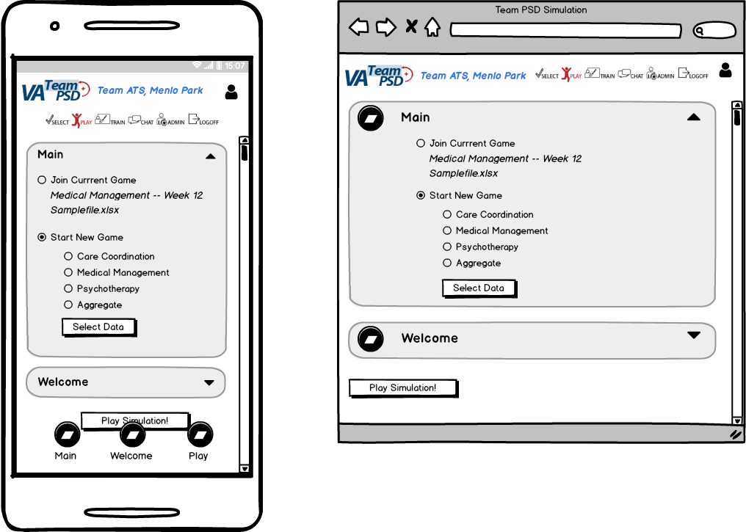  
(note: in the Top Navigation, “Select” should be highlighted, not “Play”)

* 1. The “Join Current Game” is only available if there is an active game for the user’s Group. The current game’s Vensim model selected (“Care Coordination”, “Medical Management”, “Psychotherapy”, or “Aggregate”) and current time (for example, “Week 12”) is shown on the screen.
  2. The “Start New Game” selection will have sub-selections, where the user may select the model they want to simulate. There is also a “Select Data” button, that will present a file selection dialogue box (not shown). The user will select the appropriate file to use with the model.
  3. The default radio button selected is “Join Current Game”, unless there is no current game for the user’s Group, in which case “Start New Game” is selected as the default radio button selected.
  4. For Iteration A, show all four options under “Start New Game”, but use the following chart to associate the user select with the right Vensim model.

|  |  |
| --- | --- |
| **User Selection (Radio Button)** | **Vensim Model** |
| Care Coordination | CC\_PROD.vmf |
| Medical Management | Work\_Modified.vmf |
| Psychotherapy | CC\_PROD.vmf |
| Aggregate | CC\_PROD.vmf |

* 1. The following describes the logic and screen flows when the user selects “Play Simulation”.
     1. If the “Join Current Game” is selected, user is taken to the Play Mode and associated page.
     2. If the “Start New Game” is selected:
        1. Perform a check to see if an XL file has been selected. If an Excel file has not been selected, prompt the user with a dialog box: “Please select an Excel file to bring in data for the simulation by clicking on “Select Data” above,”
        2. If an Excel file has been selected, and there is an active game for the user’s Group, prompt the user with a dialog box with the following text and two buttons “Start” and “Cancel”. “Starting a new simulation will stop the previous game for all team members. Game decisions and results may not have been saved. Do you wish to proceed?”.
           1. If user clicks “Start”, user is taken to the Play Mode and associated page.
           2. If user clicks “Cancel”, user is taken back to the Select mode and associated page.

1. **Play Mode** is selected by the user by tapping the “Play” icon on the top menu or clicking “Play Simulation” and subsequent prompts from the Select Mode. For the UI design, please see Phone Concept - left and Computer/Tablet Concept - right.
   1. If Play Mode is selected, and there is no current game for the user’s Group, a dialog box appears with the following text “There is no current game loaded for this simulation. Please go back to ‘Select’ and choose a new simulation and data file.” The user must click on the “Select” button which will take the user to the Select mode and associated page.
   2. If there is a game that is currently running for the user’s Group, the “Play” icon will turn red to indicate it is the active mode. In “Play” mode, the screen below will show. The callouts below indicate the functions (user selected actions) and features (feedback and other changing actions on the screen).

Figure 8

* 1. The **Calendar** indicates at what time increment the simulation is at. The slider, shown as a red pin, is moved along the scale by the program, as time advances (the user does not manipulate the slider). The Week number changes consistent with the scale. The user may select the number of weeks to advance the simulation, by tapping the drop down menu. The drop down menu will provide the user with 1, 2, 4 and 10 week runs and a “run-to-end selection.” The green button with the “**Run**” icon, is tapped by the user to advance the simulation. 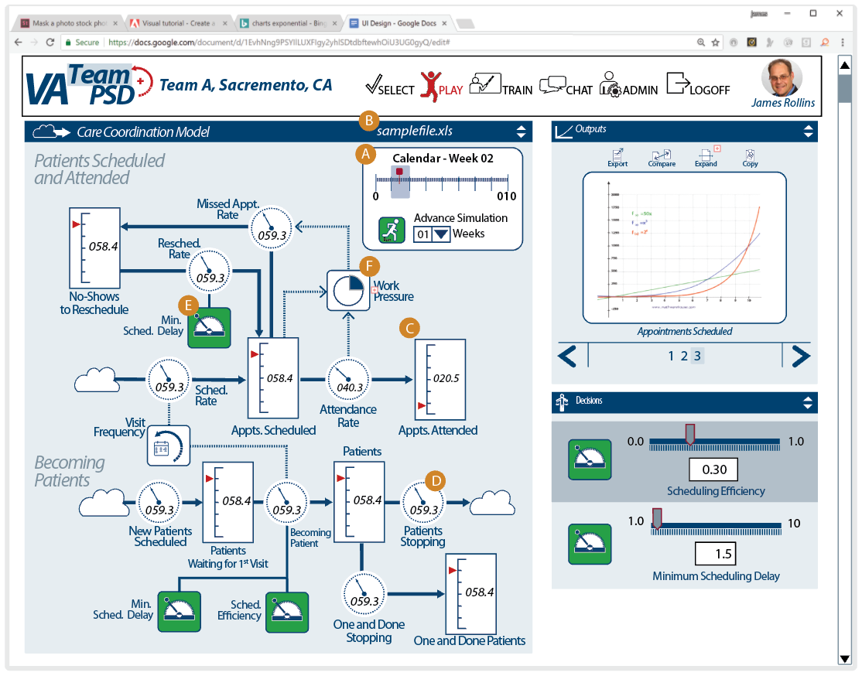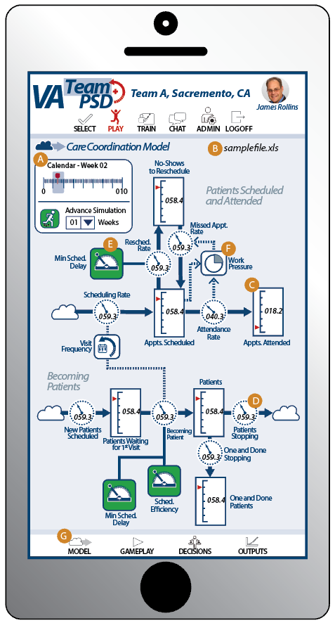
     1. For the CC model, the end calendar will be at 260 weeks (i.e., 260 is the maximum calendar step, or the maximum in the calendar).
     2. For other models, the end calendar may be at different max weeks[[1]](#footnote-1).
  2. The name of the **Data File** being resourced by the simulation is indicated on the top of the screen.
  3. **Stocks** are indicated by a rectangular scale. The range of the scale is tied to stock information contained in the model (see Vensim Variables Matrix below for associations). The Stocks indicator moves up and down the scale as the simulation advances. The value of the indicator is also displayed as a number in the middle of the scale.
  4. **Rates** are indicated by a rate dial and are tied to rates in the model. The dial will animate as the rate changes. The value of the indicator is reflected as a number below the dial.
  5. **Decision Points** are user selected variables that are indicated by green buttons in the diagram. They do not have any user interaction; however, do tell user that the variable is accessible on the Decisions Tile.
  6. **Variables**, such as “Work Pressure” and “Visit Frequency” are displayed as Chicletts, but do not actuate any functions.
  7. List of Vensim Variables to associate with **Stocks** and **Rates**:

|  |  |  |  |
| --- | --- | --- | --- |
| **Model Picture Component** | **Vensim Variable** | **Min** | **Max** |
| Scheduling Rate (Rate Dial) | CC Scheduling Rate | 0 | 50 |
| Appts. Scheduled (Stock) | CC Appts Scheduled | 0 | 20 |
| Resched. Rate (Rate Dial) | CC Rescheduling Rate | 0 | 50 |
| Missed Appt. Rate (Rate Dial) | CC Missed Appt Rate | 0 | 50 |
| No-Shows to Reschedule (Stock) | CC No-Shows to Reschedule | 0 | 100 |
| Attendance Rate (Rate Dial) | CC Attendance Rate | 0 | 20 |
| Appts. Attended (Stock) | CC Appts Attended | 0 | 5000 |
| New Patients Scheduled (Rate Dial) | CC Scheduling New Patients | 0 | 20 |
| Patients Waiting for 1st Visit (Stock) | CC Patients Waiting for 1st Visit | 0 | 5000 |
| Becoming Patient (Rate Dial) | CC Becoming a Patient | 0 | 50 |
| Patients (Stock) | CC Patients | 0 | 100 |
| Patients Stopping (Rate Dial) | CC Stopping | 0 | 20 |
| One and Done Stopping (Rate Dial) | CC One and Down Stopping | 0 | 20 |
| One and Done Patients (Stock) | CC One and Down Patients | 0 | 5000 |

* 1. To discuss: Can we make Max dynamic based on the following:
     + 1. For stocks, we can know a “starting value”, so formulaically set initial Max as ROUND ( 2 \* Initial Value ).
       2. For Rates, let the model run a tick, then use ROUND ( 2 \* Value ).
       3. For practical purposes, we can use the same logic for Stocks and Rates (i.e., timing of calculating Max)
       4. If the Value approaches 90% of Max, we recalculate (and render) a new Max.
       5. For Iteration A, please use the Max values indicated in the chart above.

1. **Play Mode - Decisions** are adjusted by the user in a separate tile, which is arrayed below the model screen on the Phone (see illustration below-left) and in a tile to the right on the Computer/Tablet (see illustration below-right).

Figure 9  
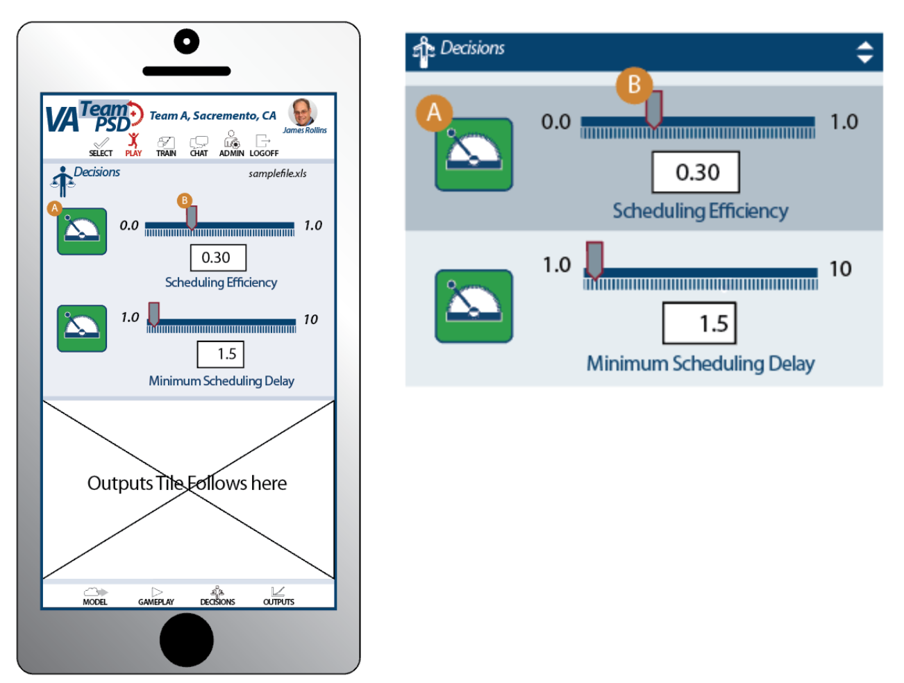

* 1. The green Decision Lever Icon is a visual aid and is not active. It references a decision point on the model screen.
  2. The decision is indicated by the user by sliding the tab on the slider, that is located above the scale. As the slider is moved up and down the scale by the user, the value is proportionally reflected in a number box below the scale. The scale reflects minimum and maximum values and units recorded in the model. Below are Care Coordination Model values:
     1. Scheduling Efficiency
        1. Vensim variable: CC Scheduling Efficiency.
        2. Range of Values: 0.00 - 1.00 (dimensionless, and no need to indicate on UI)
        3. Default value: 1.0
        4. Format: 0.00, in 0.05 increments
     2. Minimum Scheduling Delay
        1. Vensim variable: Minimum Scheduling Delay - CC
        2. Range of Values: 1 - 10 (weeks)
        3. Default value: 1
        4. Format: #0, in 1 increments

1. **Play Mode - Outputs** are arrayed below the Decisions Tile in the Phone Concept (left below) and the Decisions Tile in the Computer/Tablet Concept (right below). In the Phone concept, the user would continue to scroll down through a series of charts until they find their choice.

Figure ##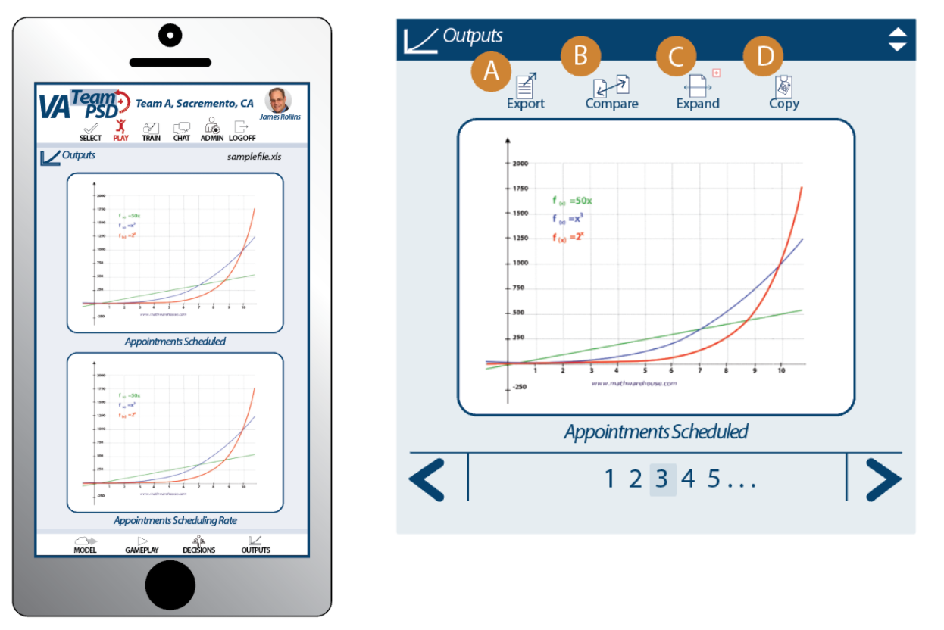

The following is an example of how we can allow users to access the different charts (from Bing).

Figure 10



* 1. The Computer/Tablet version will display outputs as a set of advancing tiles, where the user can advance through the series of charts by tapping the left or right arrows on the bottom of the tile, or by clicking directly on the number. The numbers will advance automatically, if charts number greater than 5 (see Bing example above). The user will also be able to select from a series of icons on the top of the tile to expand the view, compare and related actions.
     1. **Export:**  This function will allow the user to select a given chart and export the data.
        1. For Iteration A, open an empty dialog box with the title “Export Data” and a “Cancel” button.
     2. **Compare**: This function will provide the user a choice to select two or more charts to compare.
        1. For Iteration A, open an empty dialog box with the title “Compare” and a “Cancel” button.
     3. **Expand**: This function displays all of the charts on a single page. See below Figure ##.
     4. **Copy:** This function copies the chart to the clipboard for pasting in other applications.
        1. For Iteration A, open an empty dialog box with the title “Copy” and a “Cancel” button.
  2. Below is a sample of the **Expanded Screen Concept** that is only available on Computer/Tablet versio**n**. This expanded screen is arranged by Stocks and Flows. For Iteration A, we only need to see Appointments Scheduled and Scheduling Rate.

Figure 11

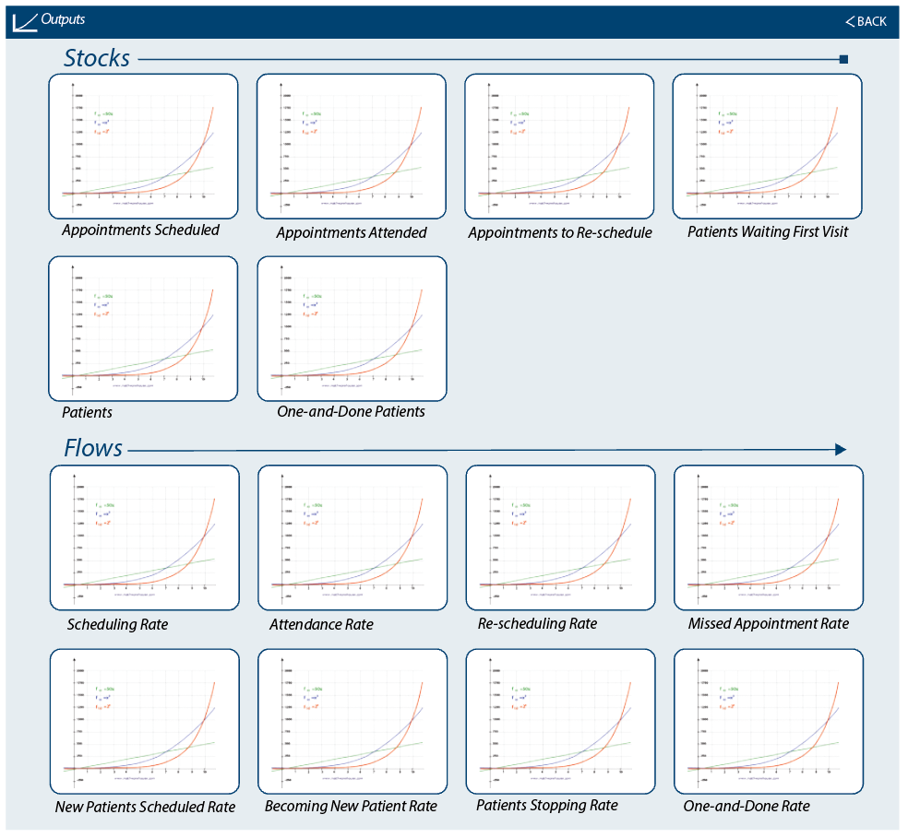

* + 1. For Iteration A, we only need to show the following as line charts.

|  |  |
| --- | --- |
| **Output** | **Vensim Variable** |
| Appointments Scheduled | CC Appts Scheduled |
| Scheduling Rate | CC Rescheduling Rate |

* + 1. Although we are showing values in the charts for only the variables listed above, include charts (that are not connected to Vensim variables) along with the labels as indicated in the UI in Figure 11.
    2. The x-axis max will be dependent on the Vensim Model selected:
       1. Care Coordination: 260 weeks
       2. Medical Management: 260 weeks
       3. Psychotherapy: 100 weeks
       4. Aggregate: 50 weeks

1. **Train** mode will provide the user with options to find needed information to properly simulate the selected model. The Train mode will enable users to select text based and screencast (video) help. For Iteration A, provide a tile that contains the necessary features to select, play, pause and close a video.

Figure 12

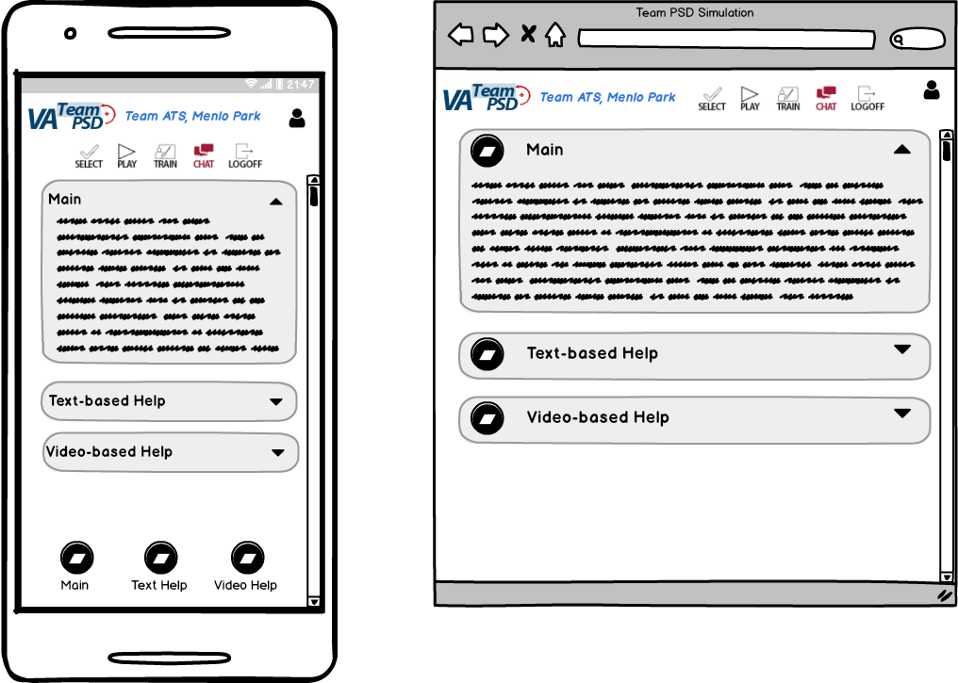

(note: in the Top Navigation, “Train” should be highlighted, not “Chat”)

1. **Chat** mode concepts (see below) show the ability for team members to text each other within the Forio environment. Notice how the Chat icon in the phone is colored red to indicate that it is active.

Figure 13  
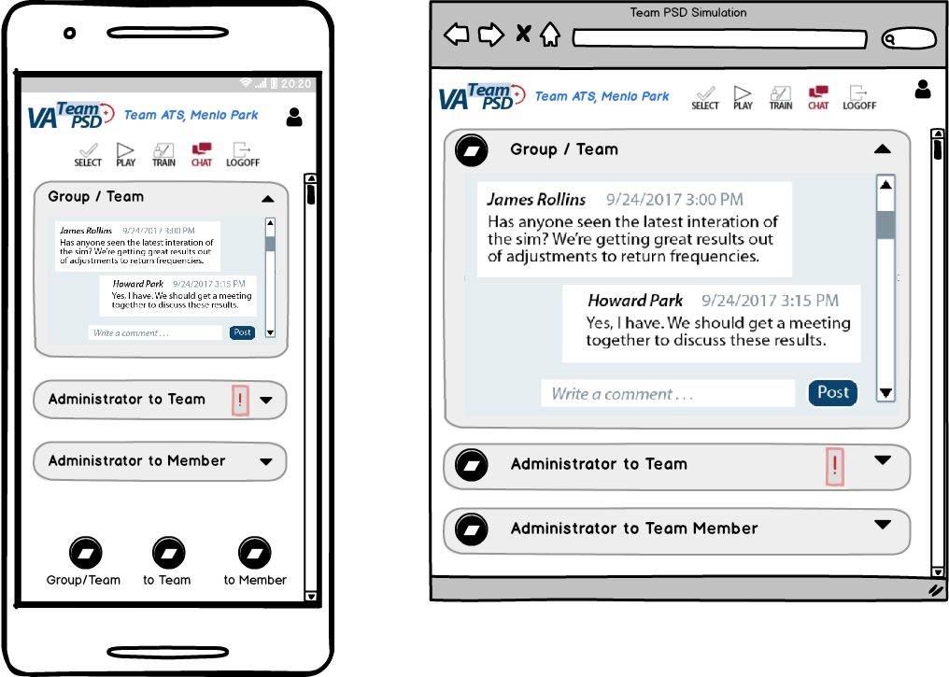

* 1. There are three sections
     1. Group/Team
        1. Any member of a team or Administrator can post and observe others’ posts to the group/team chat.
     2. Administrator to Team (for Iteration A, just have a collapsable section, as indicated in Figure 13.)
        1. Administrator View
        2. User View
     3. Administrator to User (for Iteration A, just have collapsable section, as indicated in Figure 13.)
        1. Administrator View
        2. User View
  2. Chat functionality and access through top navigation is enabled even if there is no current game for the Group.

1. **Administration Mode.** Below are wireframes of the Admin mode that indicate the the functions contained in the statement of work. The design team will require some more definition of this task before design work can proceed. Outstanding questions are:
   1. **How are team decision matrices presented**? (*see recommendations below*)
      1. Decision matrices should combine data outputs with subjective/objective values established by the team. These can be expressed as a brief narrative with assigned weights or multipliers.
      2. The values form a basis to compare alternatives and more consistently judge the best alternative. Each alternative is compared against the value, scored and rank-ordered to inform the team.
   2. **How are exogenous events introduced?** We will need to define which variables can be adjusted and describe the use-case that this event will support.

Figure 14

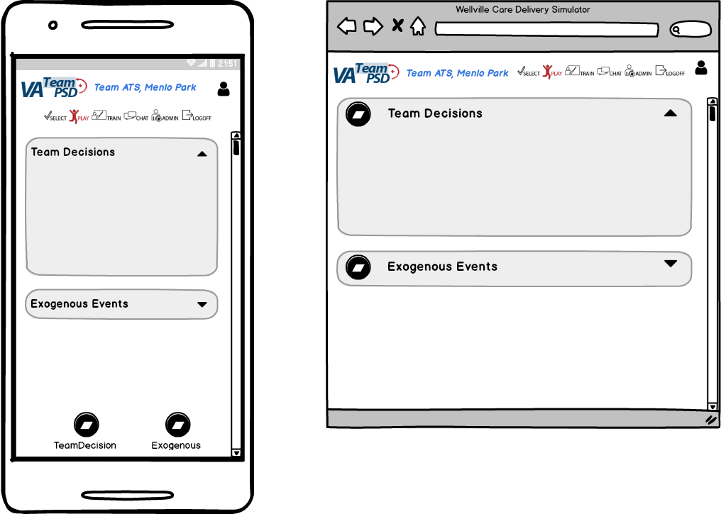

(note: in the Top Navigation, “Admin” should be highlighted, not “Play”)

1. **Logout**. When the Logout link/icon is clicked, a dialog box comes up with the following text and two buttons “Logout” and “Cancel”. “Do you want to logout?”.

# SOW Requirements

This section describes the requirements as outlined in the SOW.

We list the requirements organized by WW’s SOW, then cross-listed to VA’s SOW (Statement of Work). More detail of the mapping of tasks can be found on “VA\_PSD\_Iterations\_Features\_HCP3.xlsx”.

The headings are in the format “WW Task / VA SOW”.

## 2.01 General Functionality / 5.1.1. General Login Page

1. For Iteration A, a simple login page will work
2. Include on the Login Page
   1. Team LSD logo (see Appendix)
   2. “VA PSD Simulation”
   3. “Iteration A”

## 2.03 Player’s Dashboard / 5.9.1 General Player Functionality

General Player Functionality is embedded in the design and requirements of the Pages described above (for example, ability to advance the model clock, make decisions, etc.).

## 2.03 Player’s Dashboard / 5.9.2 Introductory Screen with Role-information and Background

Select > Welcome

Text:

**Text for Introductory Screen with Role-information and Background**

Lorem ipsum dolor sit amet, cum ex nostro equidem. Per eu habeo vidisse, mel facilis consequat adipiscing ut. Magna labitur suscipiantur vim ut, usu illum omittam ea. Habeo volutpat ex ius, brute scripserit cum an, perpetua recteque accusamus mel at.

Ex prima paulo gubergren mea, everti legimus mei ex, habemus eloquentiam qui an. Fugit zril discere mei in. Cu vix tota illum reformidans, ius reque commodo civibus in. His inciderint contentiones at, ut error aliquip salutatus eum. Has an debet forensibus dissentiunt, graece tractatos explicari ei vel, cu est soluta equidem. Agam contentiones ius id, te sea hinc aperiam convenire, ut eum sensibus percipitur suscipiantur.

## 2.03 Player’s Dashboard / 5.9.3 Ability to upload team-member pictures

This is provided by the Forio Epicenter platform.

Question: It means upload team-member picture will handle by forio dashboard?

HCP: our current understanding is that the user (through his/her Forio account) will be able to do this.

## 2.03 Player’s Dashboard / 5.9.5 Timeline information, tracking progress against schedule

Note: the following describes the design for Iteration A; there are expanded or more detailed requirements for Iteration B.

Play > Model

The simulation will show the current model time as indicated on the Pages described above.

## 2.03 Player’s Dashboard / 5.9.6 Dashboard with access to key metrics

Note: the following describes the design for Iteration A; there are expanded or more detailed requirements for Iteration B.

Play > Outputs

The simulation will show a series of output metrics as indicated on the Pages described above.

## 2.03 Player’s Dashboard / 5.9.10 Decisions Page

Note: the following describes the design for Iteration A; there are expanded or more detailed requirements for Iteration B.

Play > Decisions

The simulation will show a series of input decisions as indicated on the Pages described above.

## 2.03 Player’s Dashboard / 5.10.1 Introduction & Help: Text-based 'prepare' section

Note: the following describes the design for Iteration A; there are expanded or more detailed requirements for Iteration C.

Select > Welcome

Text:

**Text for Introduction & Help: Text-based 'prepare' section**

Lorem ipsum dolor sit amet, cum ex nostro equidem. Per eu habeo vidisse, mel facilis consequat adipiscing ut. Magna labitur suscipiantur vim ut, usu illum omittam ea. Habeo volutpat ex ius, brute scripserit cum an, perpetua recteque accusamus mel at.

Ex prima paulo gubergren mea, everti legimus mei ex, habemus eloquentiam qui an. Fugit zril discere mei in. Cu vix tota illum reformidans, ius reque commodo civibus in. His inciderint contentiones at, ut error aliquip salutatus eum. Has an debet forensibus dissentiunt, graece tractatos explicari ei vel, cu est soluta equidem. Agam contentiones ius id, te sea hinc aperiam convenire, ut eum sensibus percipitur suscipiantur.

## 2.03 Player’s Dashboard / 5.10.2 Introduction & Help: Text-based 'help' section

Note: the following describes the design for Iteration A; there are expanded or more detailed requirements for Iteration C.

Train > Text-based help

Text:

**Text for Introduction & Help: Text-based 'help' section**

Lorem ipsum dolor sit amet, cum ex nostro equidem. Per eu habeo vidisse, mel facilis consequat adipiscing ut. Magna labitur suscipiantur vim ut, usu illum omittam ea. Habeo volutpat ex ius, brute scripserit cum an, perpetua recteque accusamus mel at.

Ex prima paulo gubergren mea, everti legimus mei ex, habemus eloquentiam qui an. Fugit zril discere mei in. Cu vix tota illum reformidans, ius reque commodo civibus in. His inciderint contentiones at, ut error aliquip salutatus eum. Has an debet forensibus dissentiunt, graece tractatos explicari ei vel, cu est soluta equidem. Agam contentiones ius id, te sea hinc aperiam convenire, ut eum sensibus percipitur suscipiantur.

## 2.03 Player’s Dashboard / 5.10.3 Integrate tutorial videos

Note: the following describes the design for Iteration A; there are expanded or more detailed requirements for Iteration C.

Train > Video-based help

For iteration A, we can use the following on-line videos to embed as examples:

* Introduction to PSD Demonstration  
  <https://www.youtube.com/watch?v=HODHH5-vemw>

On which screen embed on UI? [See above]

## 2.08 Managing/Facilitating Simulations / 5.6.1 Open/Close Access to Simulation

Provided by Forio Epicenter.

# General Requirements

This section describes requirements that support the SOW Requirements, but may not be tied to a specific SOW section.

## Managing Multiple Vensim Models

1. We expect to have four separate Vensim Models as part of the Forio UI Platform. The four models (by name/description, and not by filename) are:
   1. Care Coordination (CC)
   2. Medical Management (MM)
   3. Psychotherapy (Psy)
   4. Aggregate (Agg)
2. We discussed (on Fri 25-Aug with Forio) 3 options for deploying 4 separate Vensim Files. **We decided that Option A would work for us.**

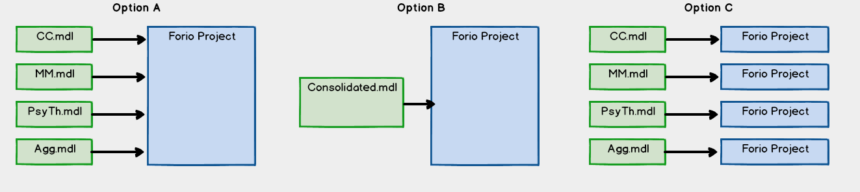

* 1. Option A -- We decided to go with Option A
     1. This will work if:
        1. We do not need more than one model being accessed per Team at a time. This includes on-going games. A game/world/session can only be accessing one model at a time.
        2. We do not need to access variables nor logic across the models.
     2. We will need to resolve how the appropriate model (and the appropriate csv file data) is/are loaded for a team’s game/world.
  2. Option B
     1. This is preferred (and is the “default” configuration); however, we think the four Vensim models will be finished at different times.
  3. Option C
     1. This could work, but it requires more Forio Projects (URLS, etc.) than planned, and also places a lot of burden on the users and admin to track URLs, userid/passwords, etc.

## Managing XL files

1. For a team, we will have one or more XL file(s), with each XL file having four sheets (tabs), with each sheet having data that can be imported into one of the four Vensim models. The Vensim models provided will already have the variables (Vensim Auxiliaries) that can be matched with the XL data.
2. UI and user implications: we need to make it easy to call up the correct data for the Team/Model combination.
3. Epicenter reference: <https://forio.com/epicenter/docs/public/model_code/vensim/vensim_example_xls/>
4. Our approach (based on discussion with Forio on 27-Sep and subsequent emails, WW tests)
   1. UI will include a way to “select an XL file form local directory”, then “upload it” to the Epicenter directory (for example under Model > XL Files).
   2. When the upload is performed, a text file (or something similar) will be updated by the UI logic that will track the name of the XL file (and also check to make sure same filename does not already exist, if so, replace after user prompt).
   3. This text file is used to build the content for the drop-down allowing users to select the XL file for import.

# Appendix

1. NC-PTSD logo (from Lucid Meetings)  
   
2. [Link](https://raw.githubusercontent.com/lzim/teampsd/teampsd_style/Team_PSD_logo.png) to Team PSD Logo (flat)
3. [Link](https://raw.githubusercontent.com/lzim/teampsd/teampsd_style/TeamPSDlogo2.png) to Team PSD Logo (square)

1. CC: Week (260); MM: Week (260); Psy: Week (100); Agg: Week (50) [↑](#footnote-ref-1)